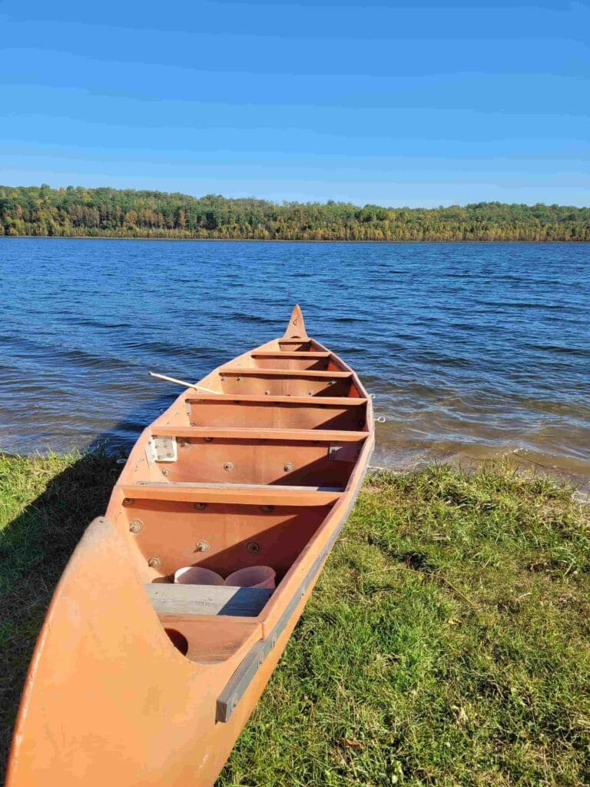  Heading out on the North Saskatchewan River  What we provide  - 20 Passenger bus to transport from departure to pick up  - 2 30 ft canoes holding 10 people  - Extra 16 ft canoes  - 2 Tandem & 2 Single Kayaks  - Fishing, Gem hunting, gold panning  - History  - Cushions & Life Jackets & Paddles & Safety Equipment
  Who We Are
  We are located out of Northern Lights RV Resort just off of Hwy 652 S of Vilna AB on RR 141
  About Us
  We provide guided tours down the North Saskatchewan River & any other local lakes. Open to all ages of people.
  Contact Us
  Phone: 587- 252-4904
  Messages: 403-336-7230
  Email: Sask.rivervog69@gmail.com
  Web: Web address
  Saskatchewan River Voyagers ltd
  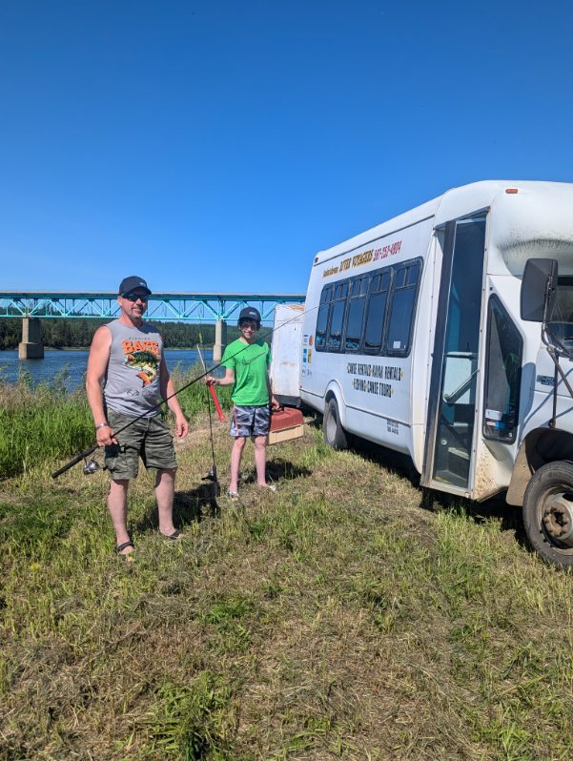
  Saskatchewan River Voyagers ltd
    - Hours:
    - Mon to Fri 8 Am to 8 PM
    - Sat to Sun 8 Am to 5 PM
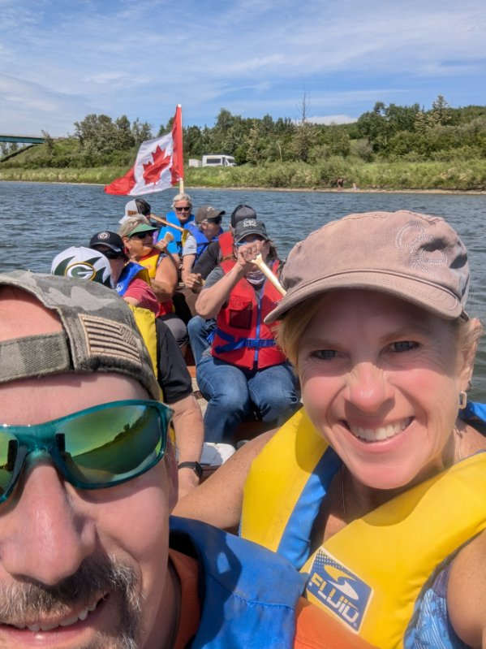  A group heading out July Long Weekend  Prices are as follows:  Adults $40.00  Children 10 to 16 are $10.00  Children under 10 are free  $10.00 per person if we transport you & your own boating unit (to and from) | Best day on the water was the day we took out both big canoes and the kids had a water fight  We will also do school functions Ask us about our rate  We accommodate to any day of the week and any time.  We have various locations that we can use along the river and we can go to any location that you would like to go to.  We accept Visa, Mastercard, American Express, Interact, Cash, Google Pay, Apple Pay  Facebook: Saskatchewan River Voyagers Ltd.  Google: Saskatchewan River Voyagers Ltd.com. | 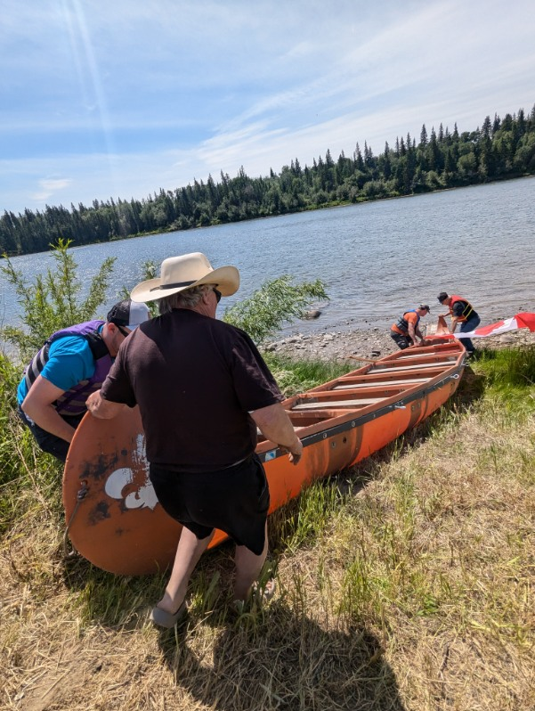  Getting ready to depart  Our Products and Services  Friendly service, 20 passenger bus  2 – 30 ft Canoes  Kayaks  4 – 16 Ft Canoes  Floating Devices

